

Education material hand-out
Arriving – a good place
→ Link to the education material: https://archiv der flucht-bildung.org

Our headline themes
Why do people become refugees?
- Arrival in Germany – What do refugees experience when they arrive in Germany? What do they need so as to feel they have reached a good place?

Video interview with MOUNA ALEEK

Background information:
Fled during the war in Syria with one son, leaving four children behind, via Turkey and Greece (by boat)

Task 1:
Watch the video with MOUNA ALEEK from the beginning or move around between sequences. Your task is to answer the following questions:
Who is the person being interviewed?
What have you learnt about them?
What do you remember best about it / what interested you most?
After this, introduce MOUNA ALEEK to your fellow students.

Task 2:
Arriving in Germany
Find out more about how this person experienced arriving in Germany and what the conditions were like by watching the sequence indicated
Sequence 1:07:27 – 1:23:00 (arrival in Germany)

Prototype – a good place
Take a sheet of paper and work together on a prototype (draught / sketch) of your “good place to arrive”

Task:

Think about the following things: What do you imagine a good place to arrive would be like?
Think perhaps about the buildings it would have. Are there certain people who could be there? What should the atmosphere be like?
→ There are no right or wrong answers, you can invent the future any way you imagine it.

CoSpaces – develop your good place digitally
Task:
Now develop your good place further:
- create a virtual environment
- choose a background
- implement your idea for a good place in CoSpaces by animating objects and text blocks

Presentation / Evaluation
At this point QR codes need to be inserted to display the good places created in CoSpaces so that the participants can see the results on their iPads or mobile phones. These devices require the CoSpaces app. If the results are to be shown on the Web browser or through VR glasses, the six-digit share code is required. You can get the QR code or share code by using the “Share” function once the created world has been activated by “Play”. As the code does not change if the world is modified, this can be done before the seminar when the CoSpace is still empty.

Here is an example of “good places” already created in CoSpaces. They need to be replaced by the relevant QR codes.

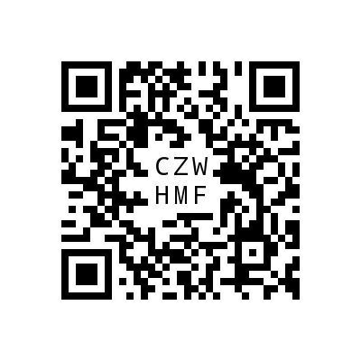
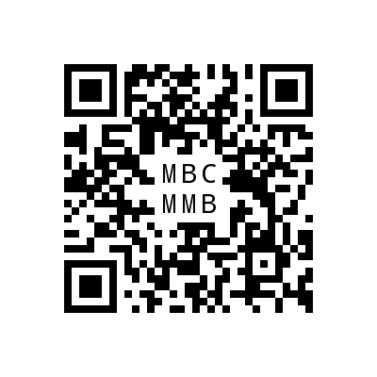
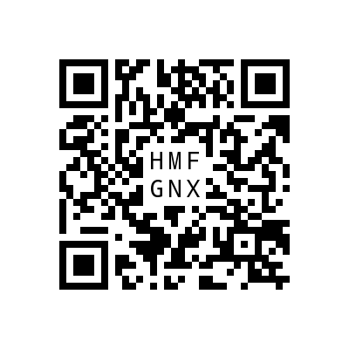
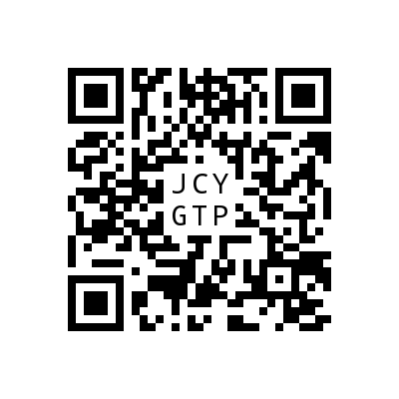
1. 2. 3. 4.

